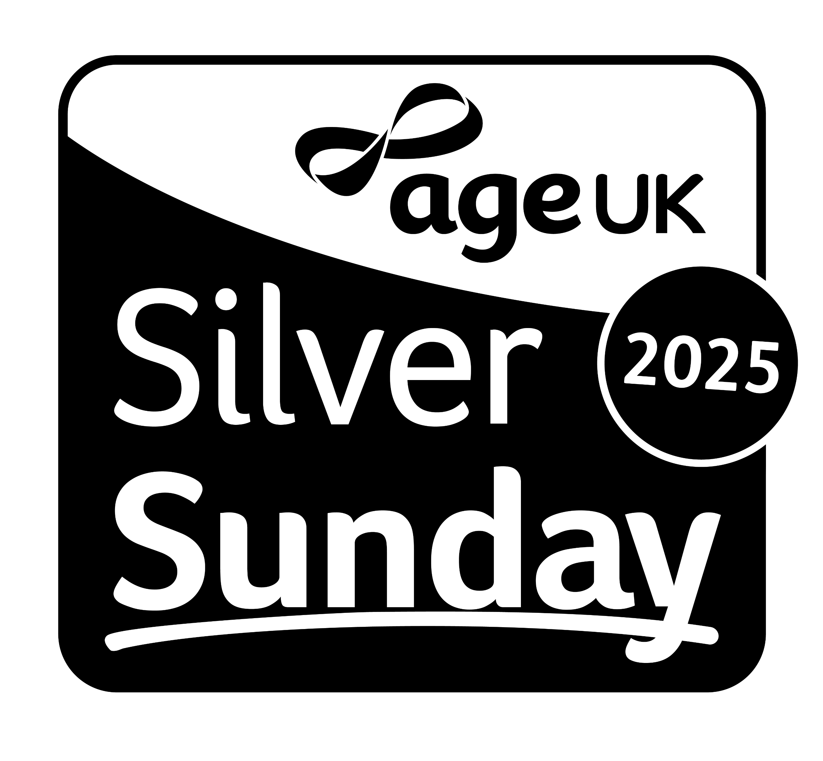
Age UK’s Silver Sunday Feedback Form
We hope that you enjoyed our Silver Sunday event. Please take a few minutes to let us know your feedback so we can use it to plan future events.
Section one: Your thoughts about Age UK’s Silver Sunday
Age UK’s Silver Sunday is a national day in October celebrating older people. Every year hundreds of events are organised by generous local groups, businesses and volunteers where older people can make new friends, try new things and connect with other generations in their local communities.
Q1. Have you attended a Silver Sunday event in previous years?
☐ Yes ☐ No

Q2. To what extent do you agree or disagree with the following statements?
 | Strongly agree | Agree | Disagree | Strongly disagree | Don’t know
Age UK’s Silver Sunday has helped me to feel part of my community | ☐ | ☐ | ☐ | ☐ | ☐
I tried something new because of Age UK’s Silver Sunday | ☐ | ☐ | ☐ | ☐ | ☐
I met new people because of Age UK’s Silver Sunday | ☐ | ☐ | ☐ | ☐ | ☐
I am likely to keep in contact with people I met because of Age UK’s Silver Sunday | ☐ | ☐ | ☐ | ☐ | ☐
I rarely get out of the house and Age UK’s Silver Sunday has helped me to get out | ☐ | ☐ | ☐ | ☐ | ☐
I found out about other local events and services because of Age UK’s Silver Sunday | ☐ | ☐ | ☐ | ☐ | ☐

Q3. How often do you generally meet up with friends or other people? [please tick one box]
☐ At least once a week ☐ Once a fortnight ☐ Once a month
☐ Strongly disagree ☐ Don’t know
Q4. How did you find out about our Silver Sunday event? [please tick as many boxes as apply]
☐ [Your organisation’s] website ☐ [Your organisation’s] magazine
☐ Email or e-newsletter ☐ Facebook or other social media
☐ Age UK’s Silver Sunday website ☐ A friend or relative
☐ Other (please state):
.......................................................................................................................................
Section two: Your thoughts about our event
Q5. Have you used a service or been to an event run by us before?
☐ Yes, often ☐ Yes, occasionally ☐ Never

Q6. Please let us know to what extent you agree or disagree with the following statements:

 | Strongly agree | Tend to agree | Tend to disagree | Strongly disagree
I enjoyed the event or activity I attended | ☐ | ☐ | ☐ | ☐
The staff/volunteers were helpful | ☐ | ☐ | ☐ | ☐
I am likely to attend similar events and activities in the future | ☐ | ☐ | ☐ | ☐
I would like to find out more about similar services as a result of this event | ☐ | ☐ | ☐ | ☐
I plan on attending similar events | ☐ | ☐ | ☐ | ☐

Q7. Do you have any suggestions as to how our event could be improved in the future? [please write below]

Q8. Do you have any general comments about Age UK’s Silver Sunday?
[please write below]

☐ I would like to know about other events organised by [your organisation]. Your details will not be passed on to other organisations.

Email address:
.......................................................................................................................................

Postal address:
............................................................................................................................................................................................................................................................................................................................................................................................................................................................................................................................................................

